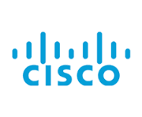

Installing Windows 11 + Software
By Gerritt Hong



Purpose:
The purpose of this lab is to install Windows 11 on a brand-new computer. After the operating system is installed, necessary drivers will be added to ensure all hardware components function properly. Additionally, important software such as PuTTY, Wireshark, and Office 365 will be installed. This setup ensures the computer is fully prepared for completing labs and activities in the Cisco CCNP course.
Background:
Operating systems are the foundation of all modern computing, and Microsoft Windows has been one of the most used platforms since the mid-1980s. Windows 11, the latest model of the operating system, has been built on decades of development, providing a modern UI, improved security features, and improved support for both personal and professional computing needs. Windows acts as a connection between the computer hardware and the user, managing system resources, running applications, and providing a graphical user interface (GUI) for easier interaction. In networking labs, a stable and updated operating system like Windows 11 is crucial for running necessary tools and performing tasks efficiently.
Installing Windows 11 on a new machine typically involves booting from an external USB flash drive. To create a bootable USB with the Windows 11 installation files, an app like Rufus is used. Rufus is a free, open-source tool that formats USB drives and copies ISO files onto them in a way that makes them bootable. This is especially useful in IT labs where multiple machines need to be set up quickly and consistently. Rufus also allows for advanced formatting options and supports different partition schemes, which is essential when dealing with various types of hardware. It has become a preferred tool among IT professionals due to its simplicity, reliability, and speed.
Once Windows 11 is installed, the next critical step is ensuring that all hardware components are fully functional by installing the appropriate drivers. Drivers are programs that allow the operating system to communicate with hardware components, such as the graphics card, network adapters, sound devices, and storage controllers. Without the correct drivers, certain hardware functions may not work properly, or performance may be degraded.
For a new PC, Windows 11 typically comes with a set of generic drivers that will allow basic functionality right out of the box. However, to ensure optimal performance, it is often necessary to download and install the latest drivers directly from the hardware manufacturer’s website. For example, network drivers are particularly important in a networking lab, as they allow the computer to connect to the internet or a local network, which is essential for accessing Cisco devices, using Wireshark for packet capture, or even downloading software updates. Similarly, video drivers should be installed for users to take full advantage of high-resolution displays, while chipset drivers improve system stability and performance.
Once the operating system and drivers are set up, the next step is to configure the environment for networking labs. This includes installing essential software such as PuTTY, Wireshark, and Office 365, which are integral to the Cisco CCNP (Cisco Certified Network Professional) course. Cisco Systems is a global leader in networking technologies and certifications. Their CCNP certification is designed for intermediate to advanced networking professionals and covers complex network solutions such as routing, switching, security, and troubleshooting. Cisco’s training labs often require not just physical or virtual routers and switches, but also specific software tools that allow users to interface with and monitor network devices.
One essential tool is PuTTY, an open-source terminal emulator that allows users to connect to network devices using protocols like SSH, Telnet, and serial communication. PuTTY is widely used because of its simplicity and effectiveness in accessing and configuring Cisco routers and switches. Since many network devices do not have their own monitors or user interfaces, tools like PuTTY are necessary for managing devices directly.
Another important tool is Wireshark, a powerful and widely used network protocol analyzer. Wireshark allows students and professionals to capture and inspect packets of data traveling over a network. This tool is crucial for learning how data moves through networks, diagnosing problems, and understanding protocols like TCP/IP, DNS, and DHCP in real time. In a lab environment, Wireshark helps students visualize what is usually invisible, network traffic, and learn to interpret packet-level data in meaningful ways.
Office 365 is also typically installed as part of the lab setup to provide access to essential productivity applications like Word, Excel, and OneNote. While not directly related to networking, these tools are useful for taking notes, writing reports, organizing lab data, and communicating within teams. Since Office 365 is cloud-based, it also reinforces concepts related to networking and connectivity, such as cloud services, data synchronization, and secure access.
Lab Summary:
For this lab, I began by downloading the official Windows 11 ISO file. Using Rufus, I created a bootable USB drive to install Windows 11 on a brand-new computer and deleted all pre-existing partitions. Once the installation was complete, I used Lenovo Vantage to automatically download and install the necessary drivers for the system, ensuring all hardware components were up to date. After ensuring everything was functioning properly, I installed key software tools for the Cisco CCNP labs, including PuTTY, Wireshark, and Office 365. These tools are essential for configuring network devices, analyzing network traffic, and handling productivity tasks within the course.
Configs: 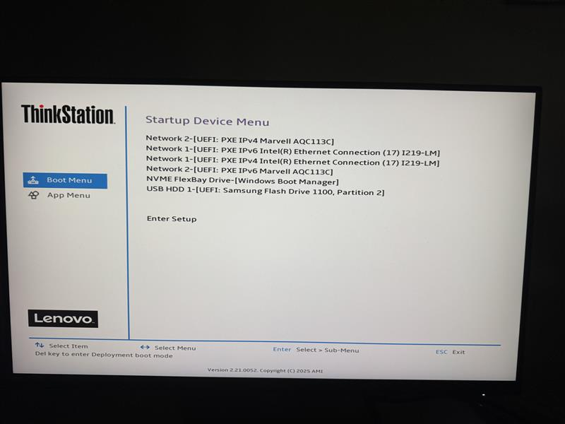
Upon Inserting your flash drive with Windows 11 on it and turning on your Computer, you need to spam F1 or F12 on your keyboard to enter the Boot Menu.
Once inside the Boot Menu you should select your flash drive with Windows 11 as your startup device.

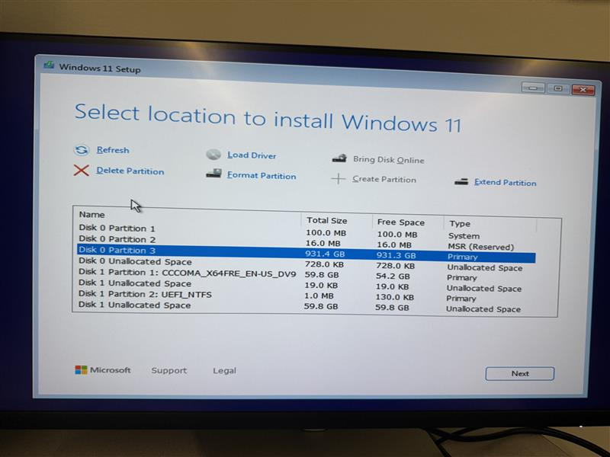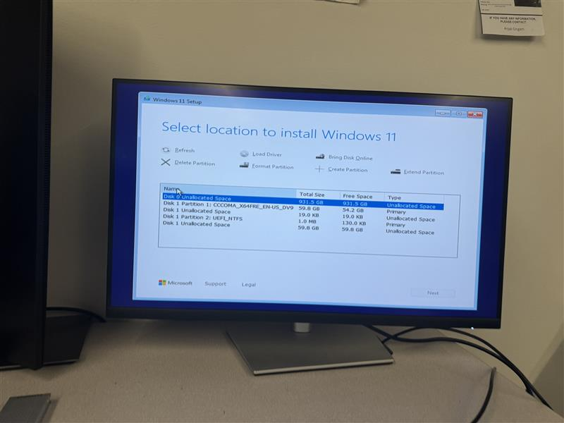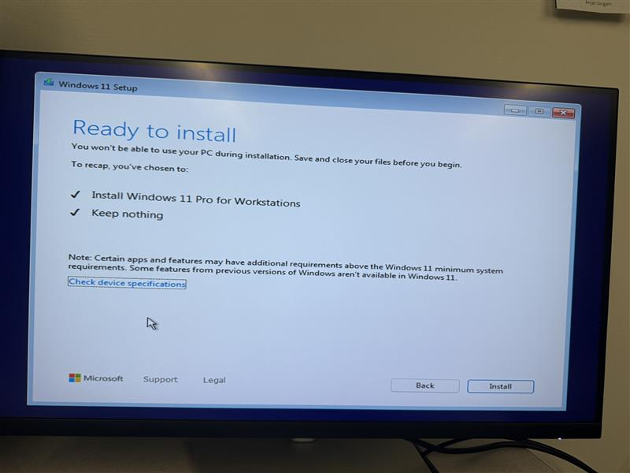
If applicable, delete any existing partitions to free up unallocated space for your windows install, then click next.
Upon clicking install, you should be booted into your hard drive. If it takes you back to the windows setup check the default startup device in the bios, and make sure it’s not your flash drive.

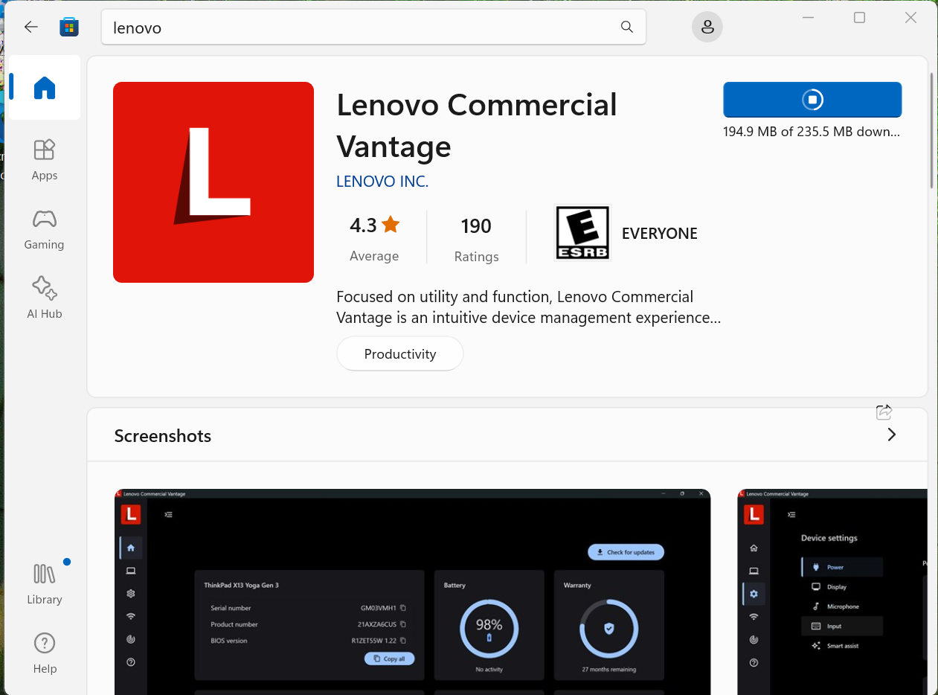
Firstly, I installed Lenovo Commercial Vantage to update my computers drivers by searching
“Lenovo vantage” in the Microsoft store.

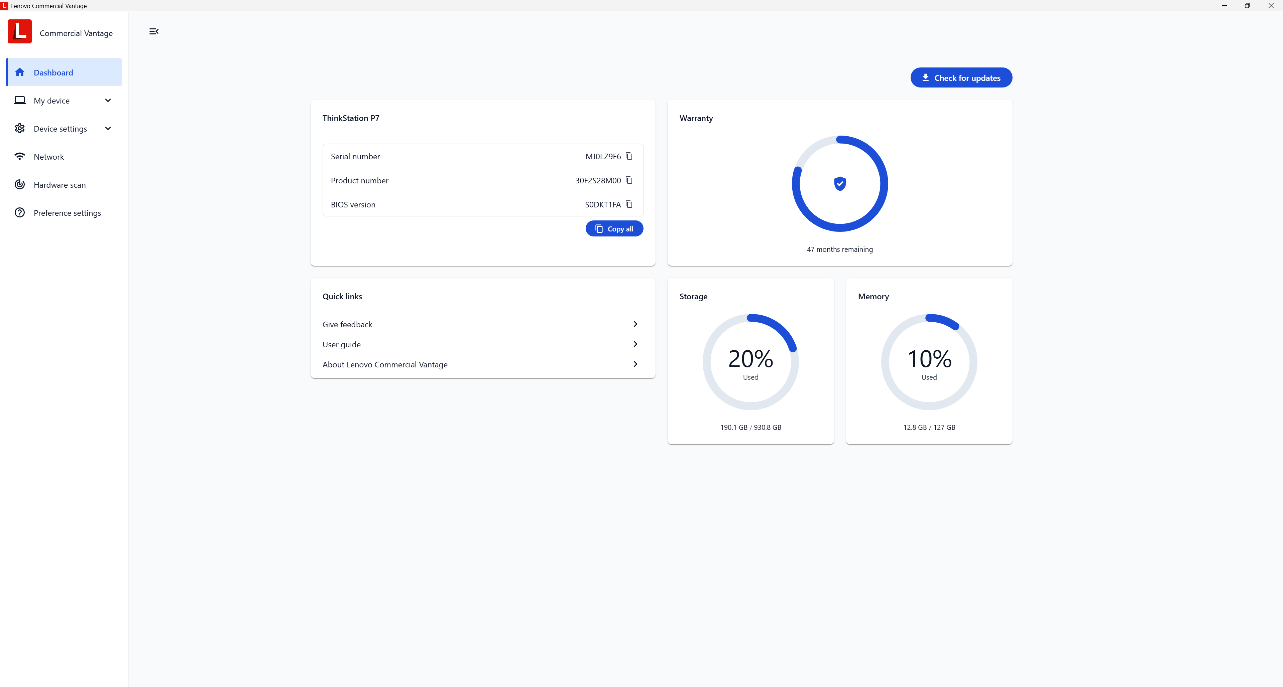
You can update your drivers by clicking the “check for updates button”. Vantage will then check for driver updates automatically once every week.

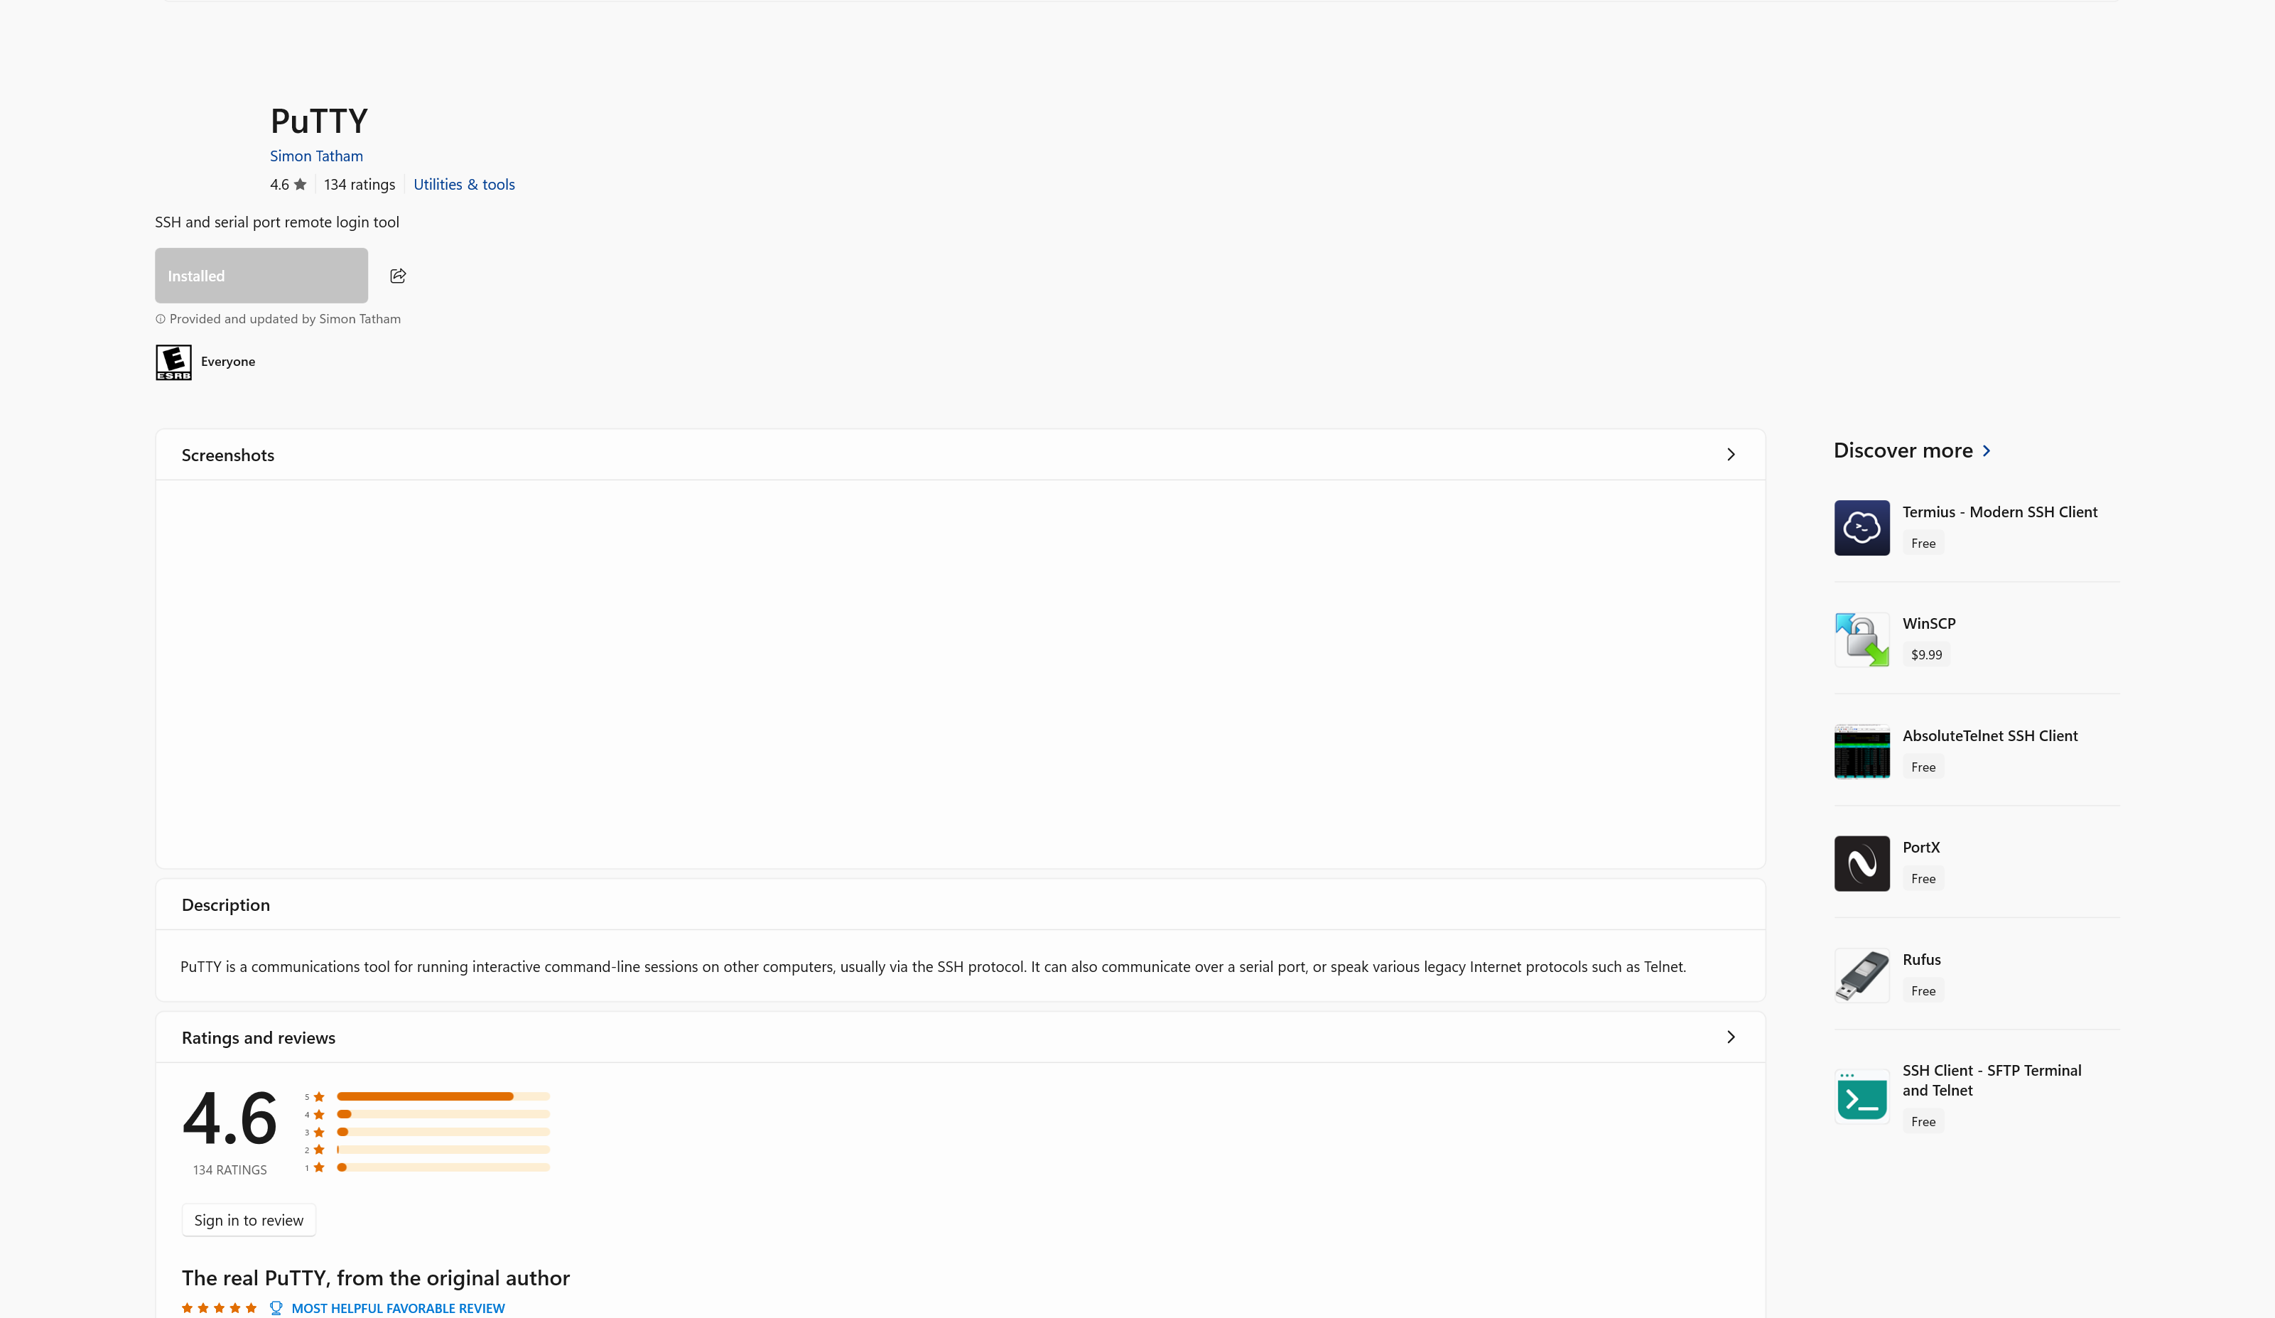
Next, I installed PuTTy by searching “putty”and installing it, then running the setup.
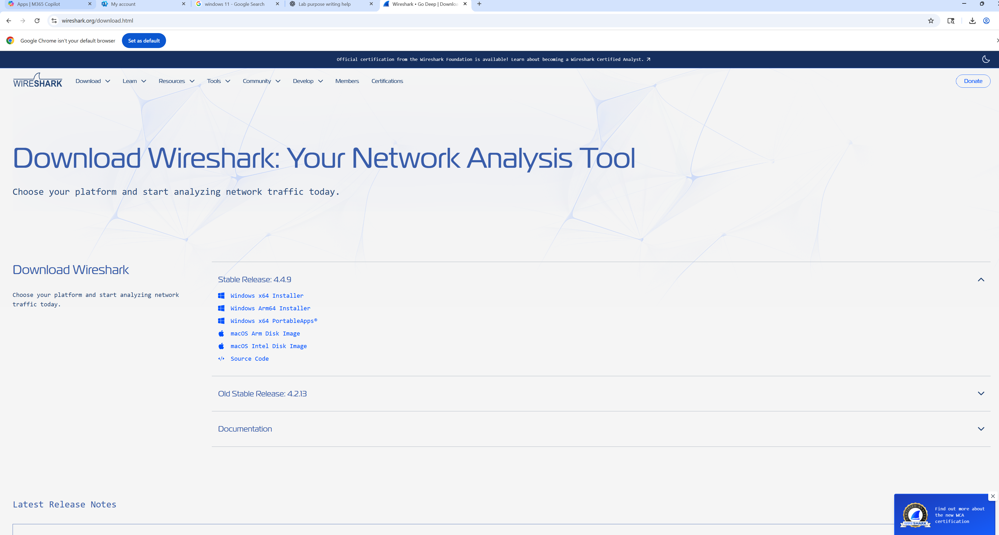
Next, I installed the Wireshark app by going to “wireshark.org” and downloading the installer.
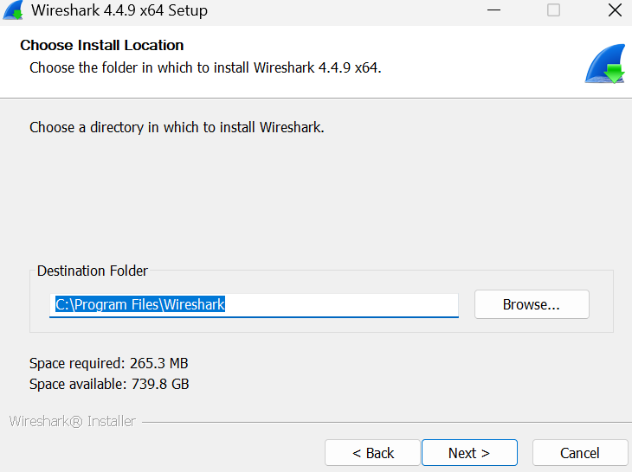
Next, run the setup and select your download destination folder.

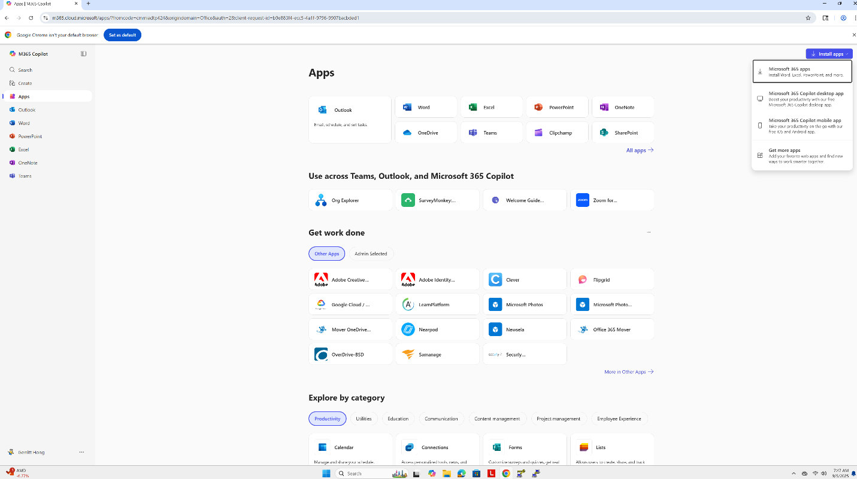
Next, to install Office 365, go to “office.com”and log in or create a Microsoft account. Click the
“Install apps” dropdown in the top right corner. And click “Microsoft 365 apps”
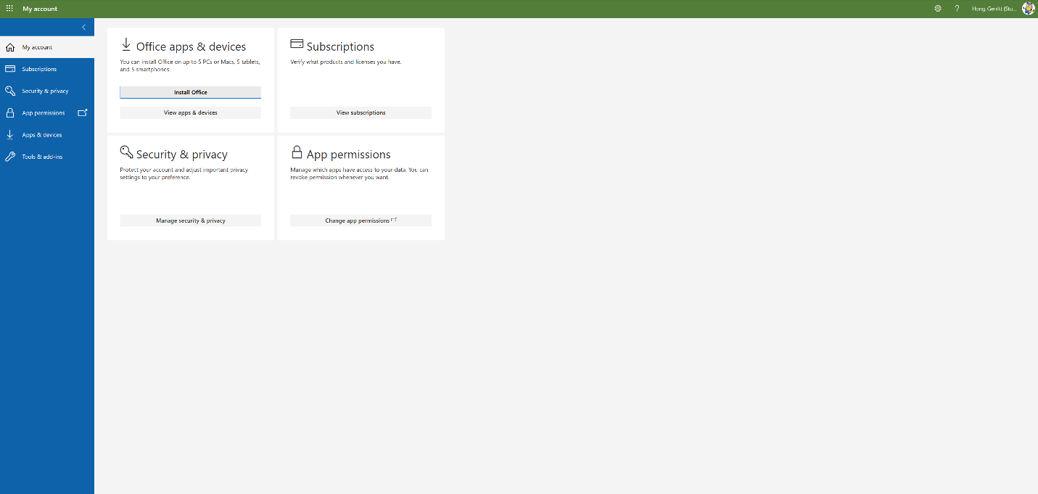
Next, simply click “Install office” to install Office 365 and all its apps(Word, Teams, PowerPoint, Excel).

Problems:
During this lab, I encountered several challenges that required troubleshooting and problem-solving. One of the initial issues was with Wi-Fi connectivity during the software installation process. I repeatedly faced difficulties when trying to download and install necessary applications like PuTTY, Wireshark, and Office 365, as the Wi-Fi kept disconnecting or did not have enough signal strength. To resolve this, I tried troubleshooting and switching between Wi-fis, trying to find a more stable connection, and eventually succeeded in downloading the applications when there was less traffic on the network. Another problem arose when I was looking for a Windows 11 flash drive to install the operating system. In our class, there were only about ten flash drives available, but not enough for everyone. This led to a delay as I had to wait for a free flash drive to become available. Once I got a working one, I proceeded with the installation. After installing Windows 11, I ran into another issue: my monitor wasn’t displaying anything. I realized I had forgotten to cable the monitor to the computer properly, which required some adjustment on my part. After connecting the monitor’s cable to the correct port, I was able to get the display up and running. Additionally, I encountered some confusion while trying to install the necessary apps. Office 365 and other utilities weren’t installed automatically as expected, and I had to search online to figure out the best solution to get them working. I found helpful guides and forums that explained how to install the required apps manually and troubleshoot common installation errors. To fix the installation problems regarding Office 365, I simply had to log in to my school account via “access work or school” tab under settings. After following these instructions, I was able to successfully install all the software required.
Conclusion:
In conclusion, this lab provided valuable experience in troubleshooting and system setup, highlighting the importance of attention to detail and problem-solving when faced with technical challenges. I learned how to efficiently install and configure a new operating system, manage drivers, and troubleshoot connectivity issues, skills that are essential for real-world IT work. This experience reinforced the significance of problem-solving, as I had to rely on external resources and adapt to unexpected delays. Overall, this lab was an essential step in preparing for more complex tasks in the Cisco CCNP course and beyond.

